IB Dance Seniors Summer Assignments:

Creating solos: use the below diagram to help generate dance choreography efforts in your intentions.

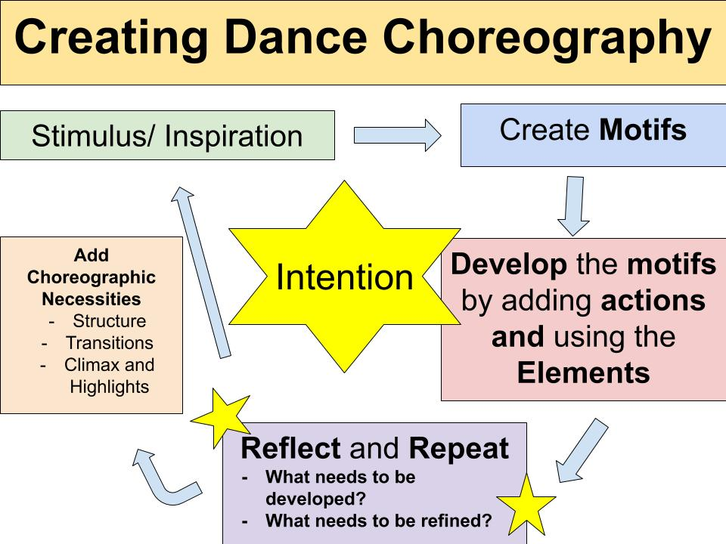

You will be asked to create 3 different solos over the summer. For each solo you will also create written evidence showing performance intentions (Supported by Programme notes) and a critical reflection on each piece.



Must have access to Mr. Nordstrom’s One Drive for IB Dance Summer Assignments folder. Please email me asap to be added to this folder. I can add from any email or directly from your R2D2 number your choice.

[Nordstrome@pcsb.org](mailto:Nordstrome@pcsb.org)

Assignment 1: Solo

Locate the folder Solo 1 within the Summer Assignments – Creating a solo folder in Mr. Nordstrom’s one drive. Use the above information to create a solo with the song in the folder. Song is called “The Human Plague” by yMusic. Please feel free to cut and splice the music to your liking (must be 3:00 in length). Use a Journal Notebook to capture choreographic notes, counts, and your thoughts on the dance. Once created make sure to record in all blacks in a studio setting with lights or outside for records and write your Programme Notes and Critical reflection.

Assignment 2: Solo

Locate the folder Solo 2 within the Summer Assignments – Creating a solo folder in Mr. Nordstrom’s one drive. CHOOSE only one (1) song (I have placed 7 to choose from). Develop a solo for this one song same as above, assignment one. Please feel free to cut and splice the music to your liking (must be 3:00 in length). Use a Journal Notebook to capture choreographic notes, counts, and your thoughts on the dance. Once created make sure to record in all blacks in a studio setting with lights or outside for records and write your Programme Notes and Critical reflection.

Assignment 3: Solo

Find and locate a famous piece of Art. Based on this piece of Art develop a solo that represents this piece of art. Find a song of your choosing that fits the chorography intentions you plan to develop based on this piece of Art. Write out your intentions and the meaning behind this art piece, song choice, and stylistic approach to choreography. Use a Journal Notebook to capture choreographic notes, counts, and your thoughts on the dance. Please feel free to cut and splice the music to your liking must be 3:00 in length. Once created make sure to record in all blacks in a studio setting with lights or outside for records and write your Programme Notes and Critical reflection.

Any questions please reach out to me for clarification.